Consumer Complaint Data Exploratory Analysis

Xixiang Chen

The Consumer Financial Protection Bureau (CFPB)’s consumer complaint database is established for two goals: enforcing federal consumer protection laws more vigorously and analyzing consumers, financial services providers and market activities. Consumers can submit their complaints about different financial areas to the database. In this analysis report, the goal is to find out the top areas of consumer complaints from CFPB’s consumer complaint database and to provide suggestions based on the problems. The analysis figures out that the credit reporting issues account for almost half of the consumer complaints, and the major problems of credit reporting include:

* Poor information management
* Unfair CFPB's rules
* Communication problem
* Data transparency problem

A closer look at the credit reporting issue data can help to potentially improve market efficiency and reduce consumer complaints.

# Overview: Credit Reporting issues driving the majority of the complaints from May 2017

The original dataset was downloaded from the Consumer Financial Protection Complaint Database. The dataset contains 17 variables and 774,859 observations, date starting from 05/01/2017.

Consumer complaints can be divided into nine types of products. The number of different product types is shown as followed.

**Table 1: Counts of Product Type**

|  |  |
| --- | --- |
| **Product Type** | **Counts** |
| Credit reporting, credit repair services, or other personal consumer reports | 364032 |
| Debt collection | 140140 |
| Credit card or prepaid card | 71536 |
| Mortgage | 70957 |
| Checking or savings account | 60188 |
| Student loan | 24429 |
| Vehicle loan or lease | 16247 |
| Money transfer, virtual currency, or money service | 14829 |
| Payday loan, title loan, or personal loan | 12501 |

**Figure 1: counts of Product Type**

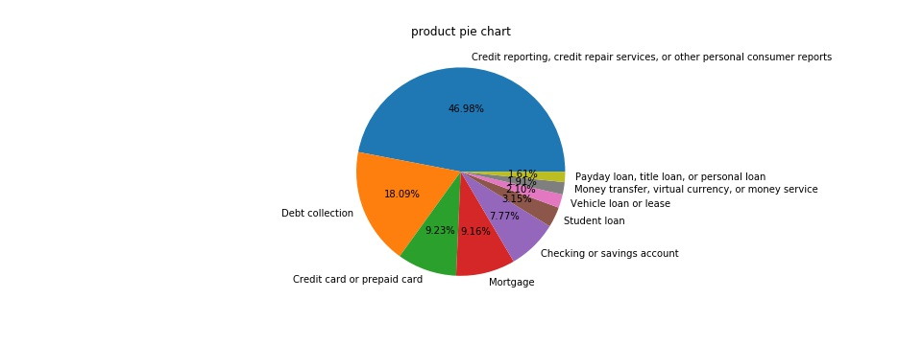

From Figure 1, we can see that almost 50% of the consumer complaints are about credit reporting issues. We also use the consumer complaint narratives to do natural language processing to find out the top topic about the complaints. The result is shown as a word cloud figure(Figure 2). In the figure, the more frequent the word shows in narratives, the larger the word shows in the figure.

**Figure 2: word cloud of complaint narratives.**

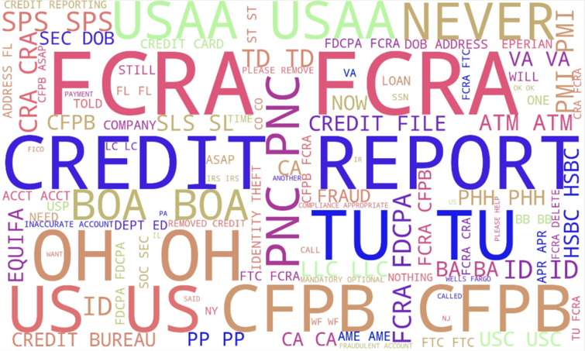

From the word cloud, we can reach the same conclusion as from the pie chart, that is, the credit reporting issues should be focused on. Therefore, we dig into this product to see what happened with credit reporting.

We calculate the percentages of the four sub-products of credit reporting, and we find that the majority of the credit reporting product complaints come from the credit reporting sub-product other than other credit services or financial reports. (Figure 3)

**Figure 3: the sub-products in the credit reporting product**

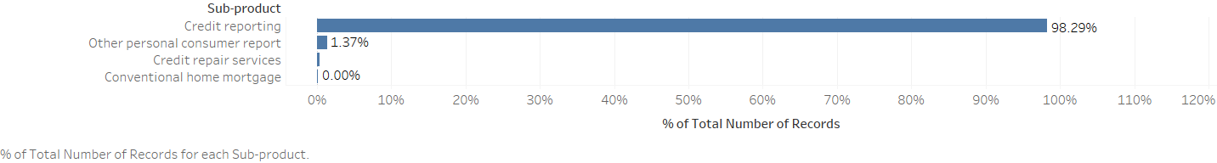

Since the credit reporting sub-product is distinguished from the other three sub-products, we count the issues of the credit reporting sub-product (Figure 4), to figure out the main problems with it.

**Figure 4: issues of credit reporting sub-product**

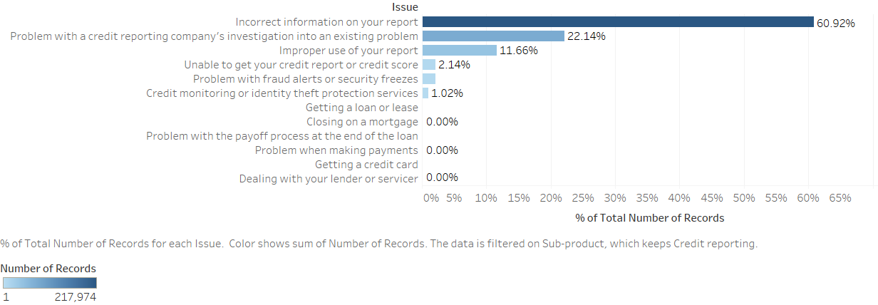

# Poor Information Management

The top one issue of the credit reporting sub-product is about the incorrect information on consumers’ reports. In this issue, there are nine types of sub-issues. The sub-issue with most complaints is that the information belongs to someone else. Other information errors related to the accounts are also complained by consumers, worthy to be paid attention to (Figure 5).

**Figure 5: sub-issues of incorrect information on your report**

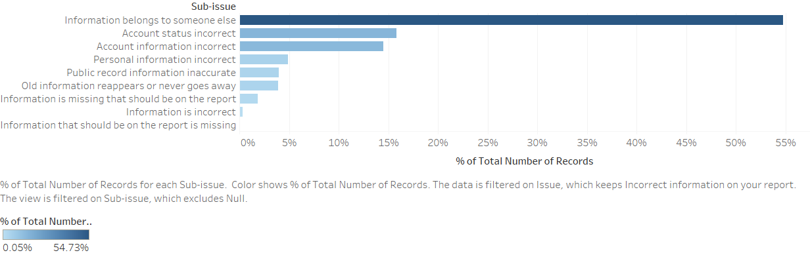

The second popular issue is the problem with a credit company’s investigation into an existing problem. When we dig into this issue, we see that most consumers complain that the credit company’s investigation is not efficient sometimes.

**Figure 6: sub-issues of problem with a credit company’s investigation into an existing problem**

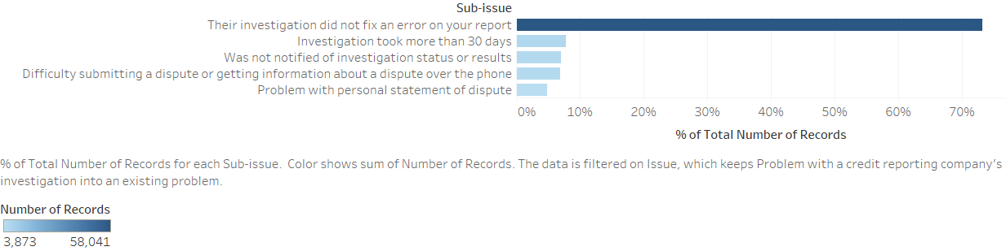

These popular sub-issues of credit reporting have revealed the problem of the poor information process of financial companies. The poor information process can lead to information errors. Sometimes when the information belongs to someone else, those whose information is shown in the wrong reports may lose their privacy.

To solve the problem, we suggest that a regulatory system be set up by the government to generate indicators and punishments for the companies’ information system. Furthermore, the industry standards of database management should be set up. The companies’ databases should be maintained periodically.

# Unfair CFPB’s Rules

We try to go further with the two issues above. Therefore, we calculate the complaints about different companies in the two issues (Figure 7). Equifax, TransUnion intermediate holdings, and Experian information solutions are the top three companies with most complaints of the two issues.

**Figure 7: complaints of companies in the two issues**

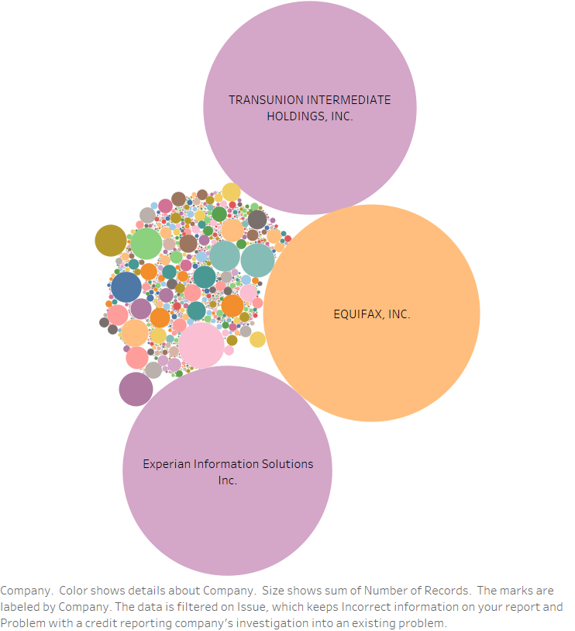

We take a look at the trend of complaints received by Equifax which has most complaints about the credit reporting, and we find out that in August 2017, the company received an abnormally large number of complaints (Figure 8). Therefore, we do some research on what happened to Equifax in August 2017. It turns out that there was a data breach of Equifax at that time, and the CFPB's rules shielded the company from class-action lawsuits in the event of an accident such as a data breach.

**Figure 8: complaints of Equifax over time**

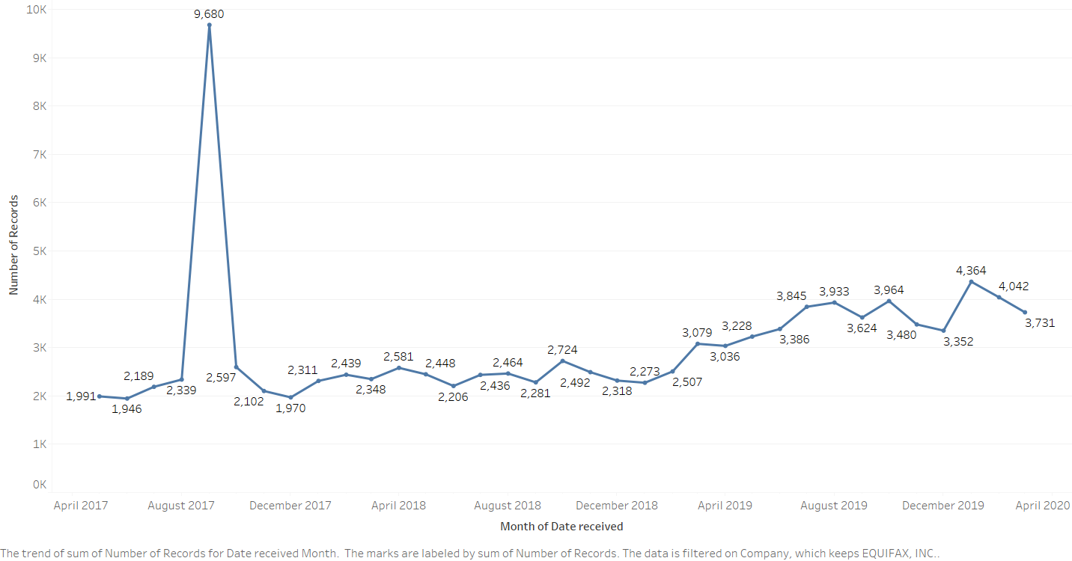

To make the market more efficient and reduce the consumers’ complaints, the CFPB's special protections that shield companies from class-action lawsuits should be repealed or amended, otherwise, the companies might keep making such mistakes.

# Communication Problem

We take a look at how companies responded to the complaints of the credit reporting sub-product and find out most responses are simple explanations (Figure 9). Compared to other responses such as non-monetary relief and monetary relief, the explanation response shows that there are two different types of responses: in favor of consumers (closed with relief) and not in favor of consumers (closed with explanation). More complaints that are not solved in consumers’ favor means complaints may be the result of customer misunderstanding rather than actual mistakes or operational errors by companies.

**Figure 9: company's response to consumers**

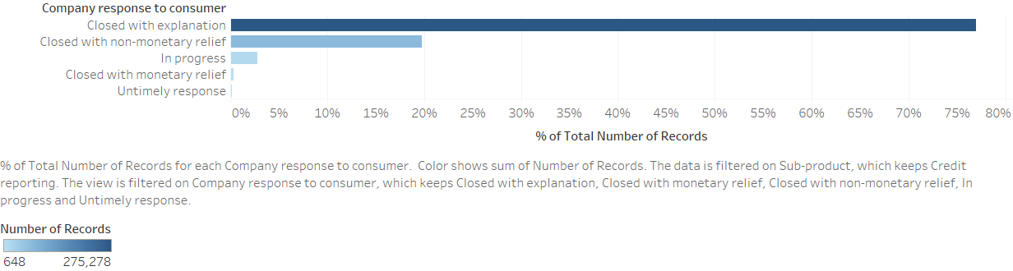

To improve market efficiency, we suggest that firms should fully explain the unclear in the contract and on the websites to consumers.

# Data Transparency Problem

We generate the bar chart of the counts of company’s’ public response and the unpublic response occupies more than 97% of the company response (Figure 10), which means to shape its image in the marketplace, a firm may not submit all complaints to CFPB, so the database can’t fully reflect a firm's complaint records.

**Figure 10: company's public response in the credit reporting sub-product**

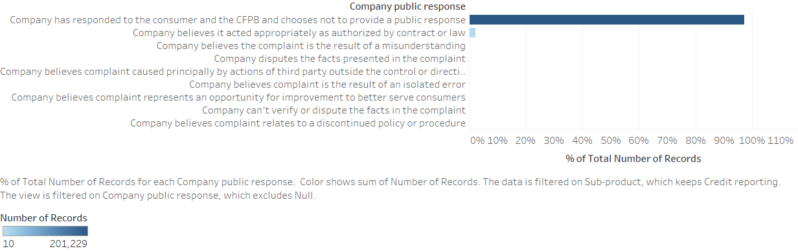

The data transparency problem is significant in the industry. Therefore, we suggest that the government should consider monitoring firms’ CFPB data and make sure that data is complete and transparent.

# Conclusion

We do a series of data analysis on this dataset about the credit reporting problem and find out some significant problems need to be fixed. We also provide our suggestions on these problems. Importantly, the industry legislations still need to be improved, to protect consumers.